Project Profile:

Things Achieved:  
Partial GPS data logging.

Challenges:  
I had messes up the connections during the connection of UART2. This was not discovered till later in the week. I kept on getting some garbage value on the screen and some pictorial output on the SD card. This made me think that there was an issue with the baud rate. But I never verified the connections. This made me stall for a good four to five days.  
This was pointed out by the professor. Since I have made the UART2 connections properly I have got the proper GPS output only once. I still think there is an issue with the baud rate of the UART1 which is connected to serial. I will have to get it resolved in this weeks’ lab.

What I learned:   
To check the datasheet and make the connections accordingly. And to verify them again once the output is not what I desired.

Plans for the next Week:  
I will be consulting the professor regarding the GPS data. Once that is done we can begin logging the data into the file and testing if the system works on battery and if the instrument sustains the environmental conditions. Then we will have a Java or C++ program to read the files that are present on the SD card once it is inserted into the workstation. This program will have a parser function to let us know the number of steps and .the distance covered by an individual using the Step Counter.

Block Diagram: 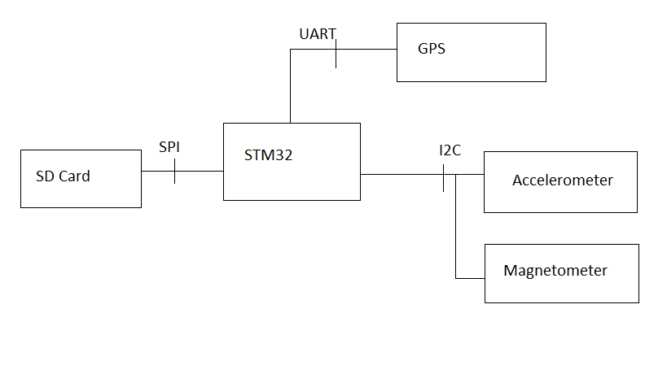

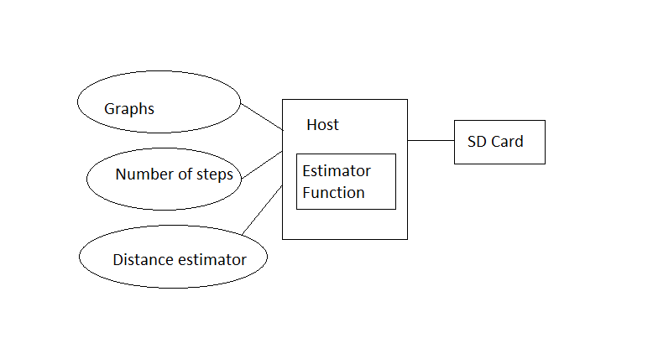

Technical Profile:

|  |  |  |  |
| --- | --- | --- | --- |
| Category | Design Objective | Deliverable | Status |
| Power | Battery Life | The battery can last for months depending upon the frequency with which it is used. |  |
| Power | Battery Availability | The system can work on commercially available 9V battery. |  |
| User Interface | Web Access | Web application should be in place to enable the user to visualize the data. | Started |
| Data Logging | Information Storage | The SD card can log in a large number of data entries. | Completed for magnetometer and accelerometer data (GPS pending) |
| Mechanical | Environmental | The system should work fine in the temperature range of -30 C to 70 C. |  |

Project Schedule for upcoming Week:

